# Lab-1

1. List all existing Database:

Query:

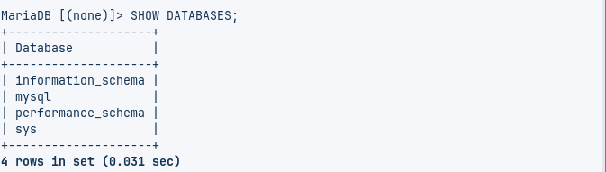

1. Create a database <your-name>dbms1 i.e. prabejdbms

Query:



1. Verify your database is created:

Query:

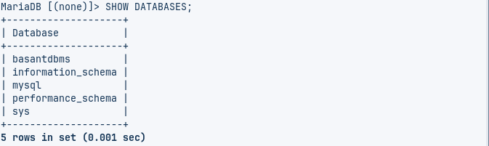

1. Select your database to perform further SQL queries

Query:



1. List all Tables in database:

Query:



1. Create tables
   * + 1. **student** (sid(int), name, gender, program)

Query:



* 1. **teacher** (id(int), name, address)

Query: **)**

1. Verify your table is created:

Query:

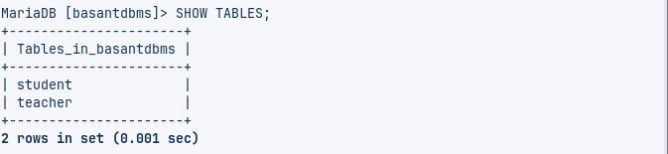

1. Check properties of Tables:

Query:

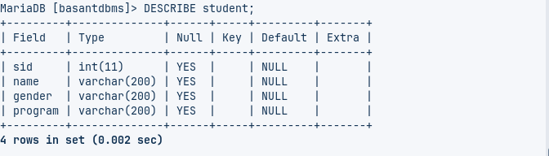

Query:

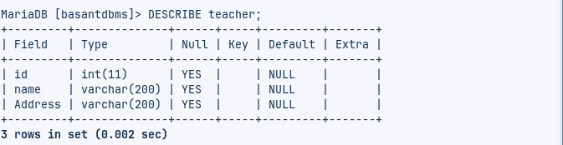

1. Add a new column (contactno. varchar(20) ) in student table  
    Query:

**  
 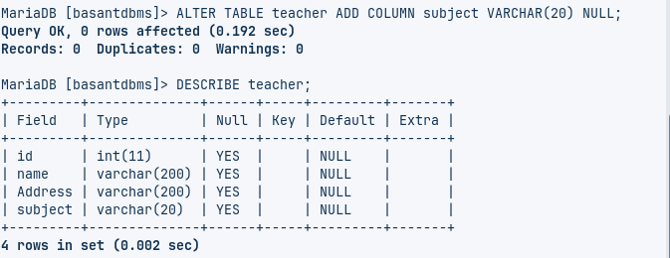**

1. Add a new column ( subject varchar(50) ) in teacher table  
   Query:   
   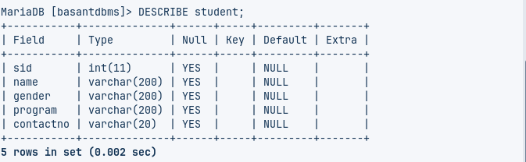
2. Change column contactno of student table to int.

Query:

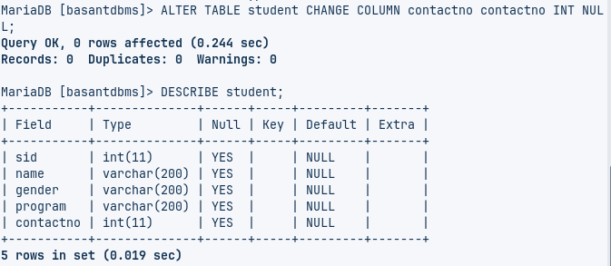

1. Change column address of teacher table to int  
   Query:

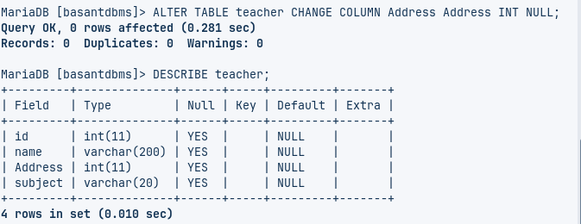

1. Drop column gender from student table  
   Query:

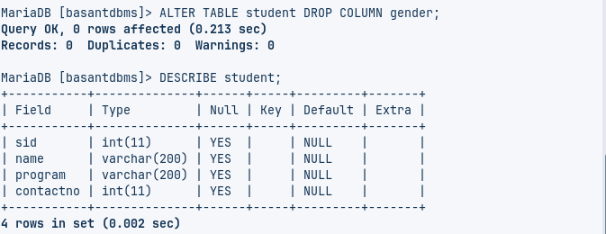

1. Drop column address from teacher table

Query:

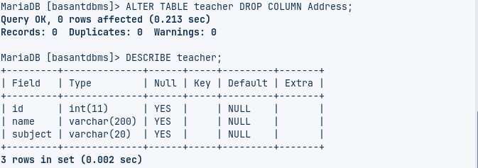

1. Change name of **name** column to **studentname**  in student table;

Query:

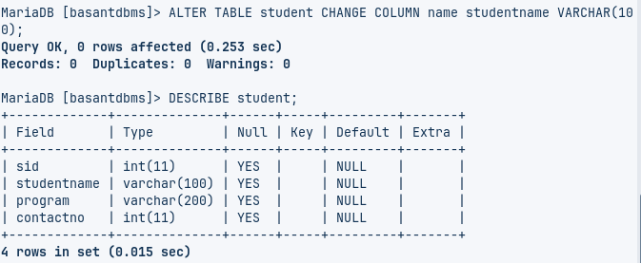

1. Change name of id column to tid in teacher table;

Query:

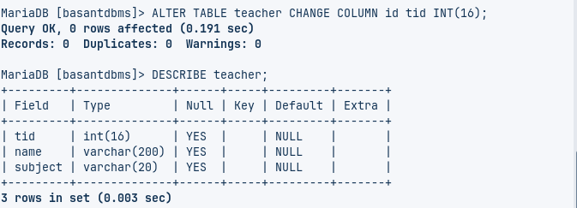

1. Drop table student:

Query:   
 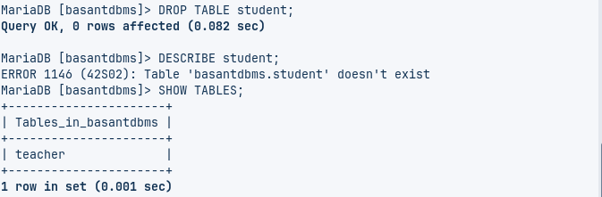

1. Drop table teacher:

Query:

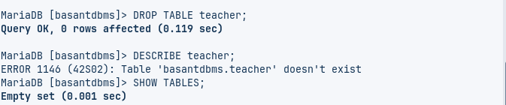

1. Drop database <your-name>dbms1:

Query:

